Washington Redskins team rules: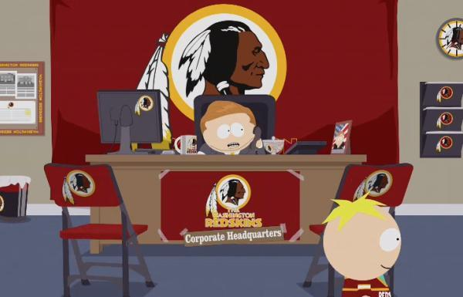

1. Be respectful
2. Be honest
3. Arrive 5 minutes early for meetings
4. Try your best
5. Don’t speak over anyone
6. If you are struggling with any work ask for help
7. If you say you will do work at least attempt it before you ask for help
8. If you can’t attend a meeting let the group know in good time
9. Before you start doing any work let the group know via the group chat what work you are starting
10. After you are finished doing the work let the group know via the group chat
11. All criticism must be constructive
12. Always have a clear idea of what task you are doing and if you don’t get clarification
13. Comment on all commits to the repository